

**UNIVERSITY INSTITUTE OF ENGINEERING**

**Department of Computer Science & Engineering**

**Subject Name:**

**Subject Code:** 20CSP358

**Submitted to: Submitted by:**

Er. Manni Kumar (E13601) Name: Yash Gupta

UID: 20BCS5009

Section: 20BCS-DM-716

Group: B

**INDEX**

|  |  |  |  |  |  |  |
| --- | --- | --- | --- | --- | --- | --- |
| **Ex. No** | **List of Experiments** | **Conduct (MM: 12)** | **Viva**  **(MM: 10)** | **Record (MM: 8)** | **Total**  **(MM: 30)** | **Remarks/Signature** |
| 1.1 | Familiarisation with Arduino hardware and perform necessary software installation. |  |  |  |  |  |
| 1.2 | Identification of different sensors used in IoT applications. |  |  |  |  |  |
| 1.3 | Demonstration of Autodesk Tinkercad Simulation Platform. |  |  |  |  |  |
| 2.1 | Program to interface the Arduino with LED and blinking application. |  |  |  |  |  |
| 2.2 | To measure the distance of an object using an ultrasonic sensor. |  |  |  |  |  |
| 2.3 | Interfacing of Arduino with temperature and humidity sensor with real time application. |  |  |  |  |  |
| 2.4 | To display data generated by sensor on LCD using Arduino/Raspberry Pi. |  |  |  |  |  |
| 3.1 | Interfacing Air Quality Sensor (MQ135) and display data on LCD. |  |  |  |  |  |
| 3.2 | Real time application of controlling actuators through Bluetooth application using Arduino. |  |  |  |  |  |
| 3.3 | Study the Implementation of Zigbee Protocol using Arduino. |  |  |  |  |  |

**Experiment 1.1**

**Student Name: Yash Gupta UID: 20BCS5009**

**Branch: BE-CSE Section/Group:20BCS_DM-716 B**

**Semester: 6 Date of Performance: 13/02/23**

**Subject Name: IOT LAB Subject Code: 20CSP_358**

## Aim:

Familiarizing with Arduino hardware and perform necessary software installation.

## Objective:

* To study hardware and software related to IoT
* To understand the function of Node MCU, Arduino Uno and Raspberry Pi.

**Arduino Board**

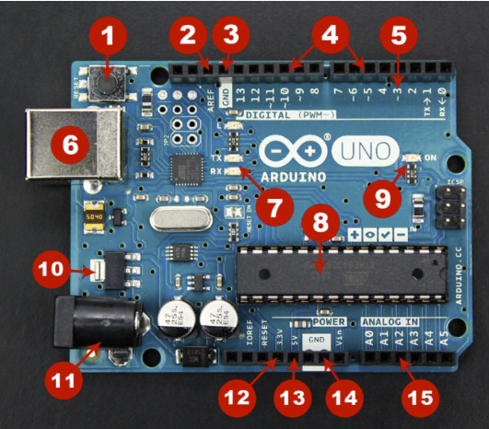

**Board Breakdown 🡪**

1. **Reset Button** – This will restart any code that is loaded to the Arduino board.
2. **AREF** – Stands for “Analog Reference” and is used to set an external reference voltage.
3. **Ground Pin** – There are a few ground pins on the Arduino and they all work the same.
4. **Digital Input/Output** – Pins 0-13 can be used for digital input or output.
5. **PWM** – The pins marked with the (~) symbol can simulate analog output.
6. **USB Connection** – Used for powering up your Arduino and uploading sketches.
7. **TX/RX** – Transmit and receive data indication LEDs.
8. **AT mega Microcontroller** – This is the brains and is where the programs are stored.
9. **Power LED Indicator** – This LED lights up anytime the board is plugged in a power source.
10. **Voltage Regulator** – This controls the amount of voltage going into the Arduino board.
11. **DC Power Barrel Jack –** This is used for powering your Arduino with a power supply.
12. **3.3V Pin** – This pin supplies 3.3 volts of power to your projects.
13. **5V Pin** – This pin supplies 5 volts of power to your projects.
14. **Ground Pins** – There are a few ground pins on the Arduino and they all work the same.
15. **Analog Pins** – These pins can read the signal from an analog sensor and convert it to digital.

**Program an Arduino 🡪**

**Step 1 –** First you must have your Arduino Board and USB cable.

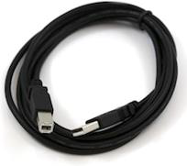

**Step 2 –** Download Arduino IDE Software from the official website.

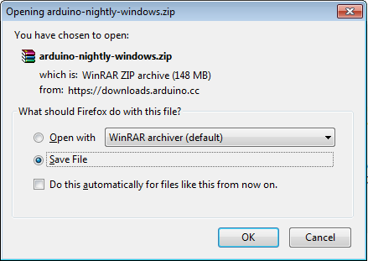

**Step 3 –** Power up your board. Connect the Arduino board to your computer using the USB cable. The green power LED (labelled PWR) should glow.

**Step 4 –** Unzip the file and Launch Arduino IDE application.

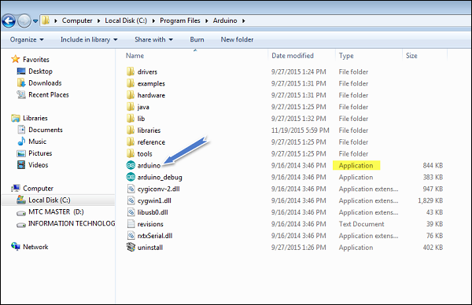

**Step 5 –** Open your first project and write your code.

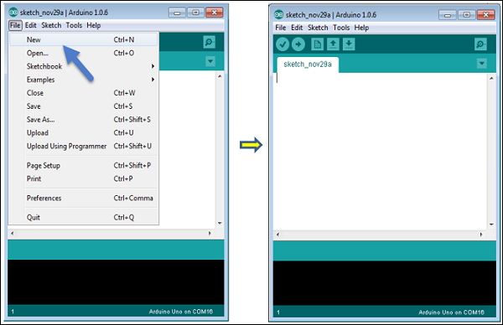

**Step 6 –** Select your Arduino board. Go to tools 🡪 Board 🡪 select your board.

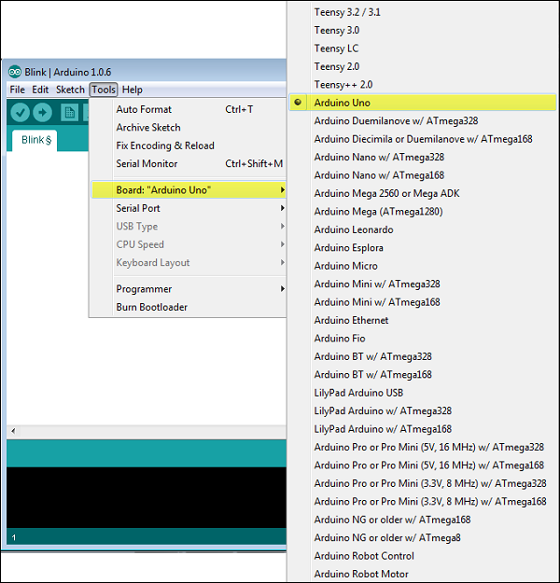

**Step –** Upload the program to your board.

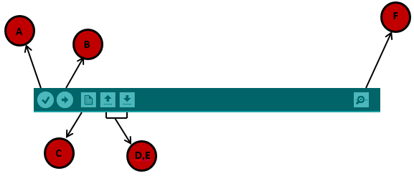

**A –** Code compiler.

**B –** Upload the code on the Arduino.

**C –** Shortcut to create new sketch.

**D, E –** To open example sketch.

**F –** Serial monitor used to receive serial data from the board and send the serial data to the board.